 C4.6
Bearings

1 Write the bearings shown by each of the following diagrams. (The first one has been done for you.)
(a)  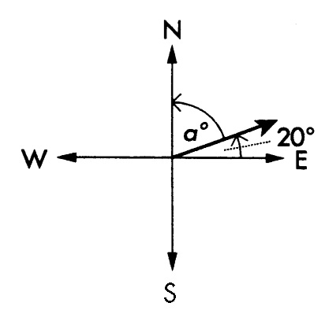 | The general direction is north-east (between north and east).  The angle made with the northerly direction = a°  = (90 – 20)°  = 70°  The bearing is N 70° E.
(b)  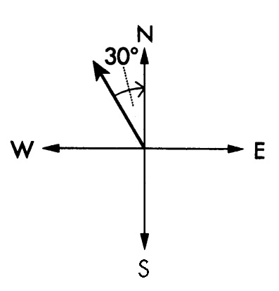 | General direction: north-west  Angle made with north: ……°  Bearing: N …..° W
(c)  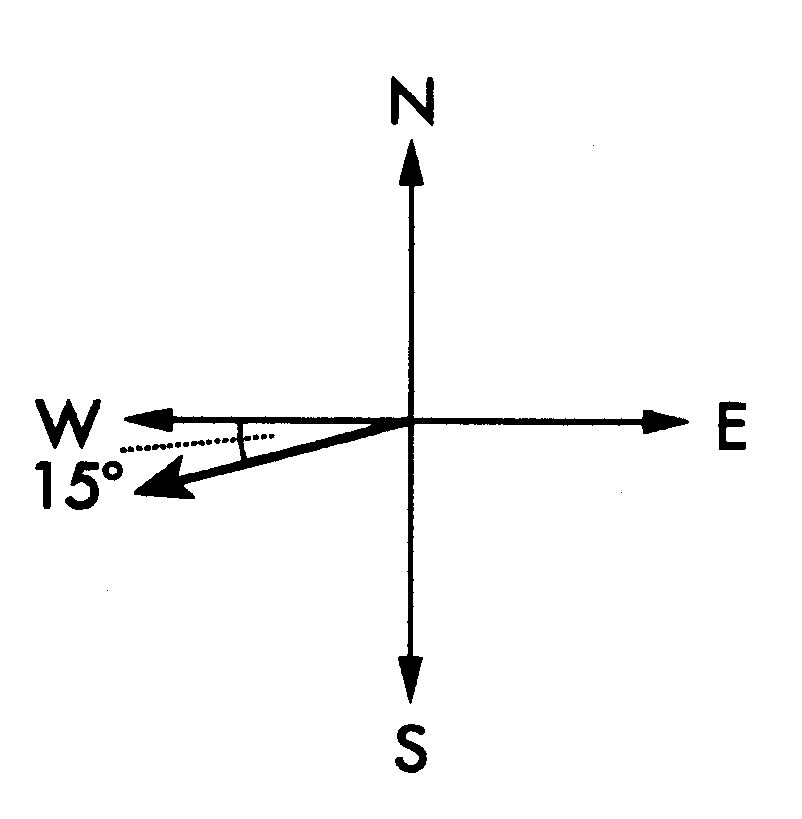 | General direction: ……-west  Angle made with south: (90 – ……)º  Bearing: S 75°……
(d)  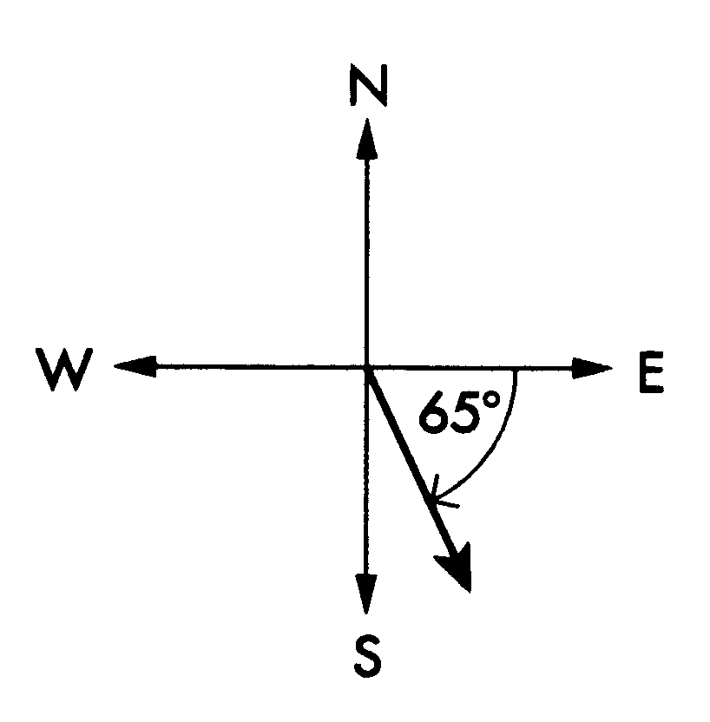 | General direction: ……-……  Angle made with south: (90 – ……)º  Bearing: S ……°……
(e)  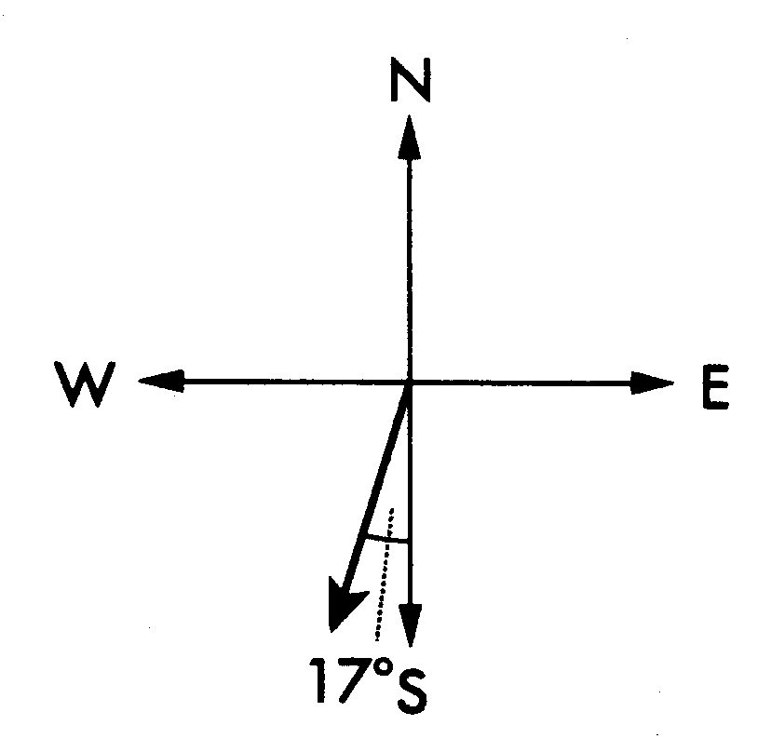 | General direction: ……-……  Angle made with ……: 17°  Bearing: …… ……°……

C4.6 (continued)

True bearings
A true bearing is the large angle drawn from the north direction line clockwise to the required line.


Find the true bearing for the diagram on the right that shows bearing S 25º E.  Big angle = 90º + 65º = 155º  The true bearing is 155º T. | 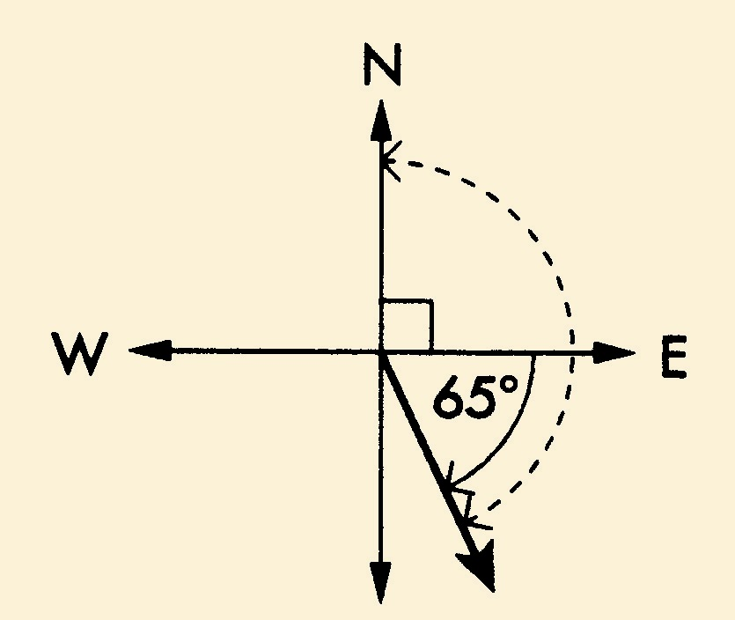

2 Find the true bearing for each of the following diagrams.
(a)  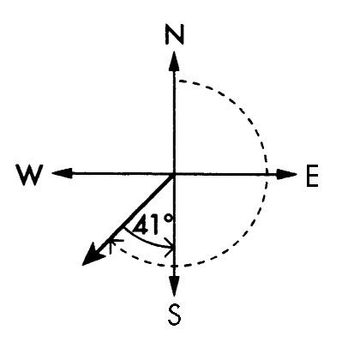 | Big angle = 180° + ……  = 221°  Bearing = ……°T
(b)  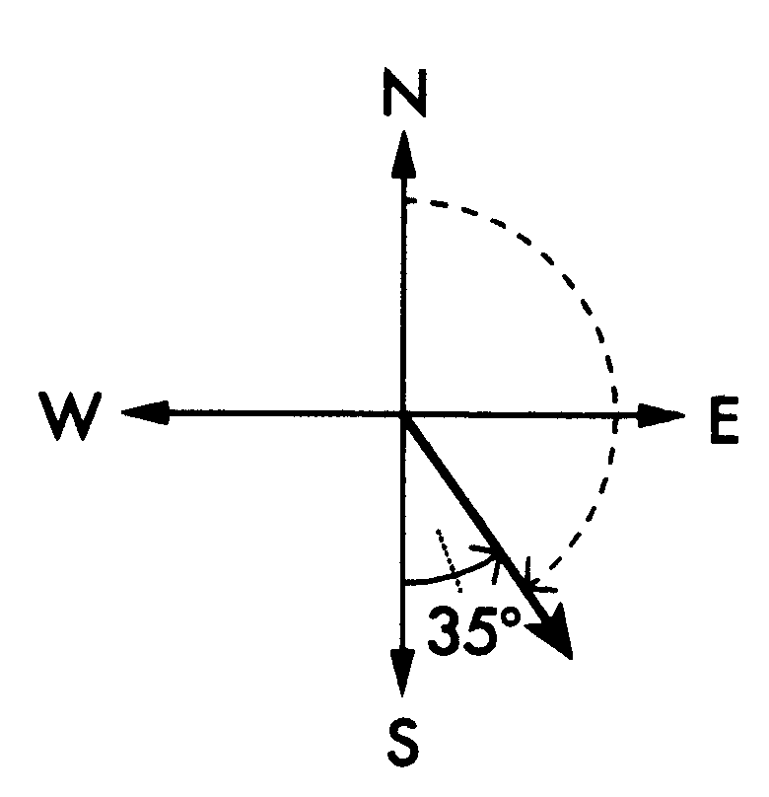 | Big angle = 180° – ……  = ……°  Bearing = ……°T
(c)  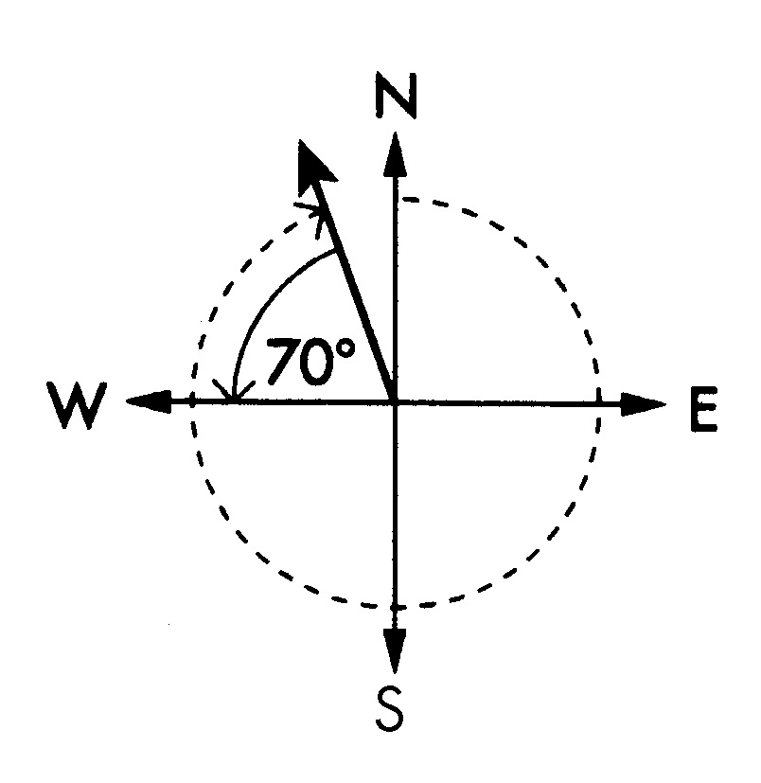 | Big angle = 270° + ……  = ……°  Bearing = ……°T
(d)  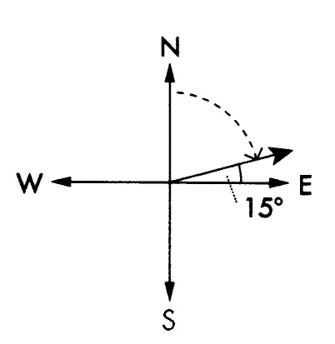 | Big angle = ……° – 15  = ……°  Bearing = ……°T

